Lecturer’s name: | Date:
Course: ELA 6 | Unit 4: Analyzing and Crafting Argumentative Texts
Unit Duration: 25 days | Lesson Duration: 45- 60 minutes
TEKS:  - 6.12J: Use an appropriate mode of delivery, whether written, oral, or multimodal, to present results.  - 6.6H: Respond orally or in writing with appropriate register, vocabulary, tone, and voice. | Lesson Part #
Topic: Respond to ideas in a variety of ways
Lesson objectives:
- SWBAT respond to ideas in a variety of ways
- SWBAT respond orally
Essential Questions:
- Where do messages come from?
- What can I learn about myself through the messages I choose to spread?
LYS Methodology
Be (Character/Values/Principles) - Educational- Inspiration
Know (What resources are available to the student/ How can they use them) - Vocational- Personal Mission
Do (Execute with Excellence) - Spiritual- Creativity
Resources (Include Technology):
- Teacher selects a verbal or written message to share with students.
- Teacher may opt to provide a list to students and allow them to select their initial source for analysis
  - https://www.ted.com/ is a great source for inspirational messages and shared ideas.
  - Some recommendations for this assignment:
    - Say Your Truths and Seek Them in Others: https://www.ted.com/talks/elizabeth_lesser_say_your_truths_and_seek_them_in_others
    - Our Unhealthy Obsession with Choice: https://www.ted.com/talks/renata_salecl_our_unhealthy_obsession_with_choice
    - The U.S. needs a Radical Revolution of Values: https://www.ted.com/talks/dr_bernice_king_the_us_needs_a_radical_revolution_of_values
    - The Tribes We Lead: https://www.ted.com/talks/seth_godin_the_tribes_we_lead
    - Should You LIve for your Resume or Eulogy: https://www.ted.com/talks/david_brooks_should_you_live_for_your_resume_or_your_eulogy
    - Life Lessons from an Ad Man: https://www.ted.com/talks/rory_sutherland_life_lessons_from_an_ad_man
    - Why winning doesn’t always equal success: https://www.ted.com/talks/valorie_kondos_field_why_winning_doesn_t_always_equal_success
    - My identify is a Superpower, not an obstacle: https://www.ted.com/talks/america_ferrera_my_identity_is_a_superpower_not_an_obstacle
    - For these women, reading is a daring act: https://www.ted.com/talks/laura_boushnak_for_these_women_reading_is_a_daring_act
    - The benefits of Expressing your Emotions (constructively): https://www.ted.com/talks/arturs_miksons_the_benefits_of_expressing_your_emotions_constructively
Instructional Input - Asynchronous
AS: Anticipatory Set (Introduction)
- Watch/ read the assigned text and reflect on the mode, message, audience, and overall tone.
Mode (how was the message delivered)
Message (what was I supposed to learn?)
Audience (who was this written for?)
Tone (what emotions were expressed?)
My personal reflections and takeaways
- Set a purpose: There are a variety of modes of communication: oral, written, and visual are only a few. In our world driven by technology, writing something down could be done in a few words or several paragraphs or pages. Saying something can include video or not and can often be shared with a simple click of a button. When we create visual messages, it is hard to know what is real and what has been filtered, edited, or completely made up. Because we have so many options on how to spread our messages, it is important to reflect on the right way to share each message based on your audience, purpose, and message. Today, you will create a short message about anything appropriate. This could be something you simply want to tell or teach people. Maybe this message will be designed to convince others to do or believe something. Or maybe you will choose to create a message that is simply designed to entertain. You will deliver this message in three different ways and it will be shared with each other, so make sure your message is not only appropriate but that you are comfortable sharing it with others.
M: Modeling (I do)
- Teacher provides a model of a message based on audience, purpose, and message using a simple chart.
- Teacher provides a model of her three modes to present her message using a simple chart.
  - Class can brainstorm and add options to a list or create a list on their own.
Audience:
(Who is this message for?)
Purpose:
(Why am I choosing THIS message? remember PIE)
Message:
(What, specifically, do I want to say about myself, my values, the world, others, etc.)
Written Options | Spoken Options | Visual Options
Tweet/ text (short)  Article/ Essay  Quote  Poem | Spoken Word Poetry  SnapChat/ Tik Tok  Short recording  Audio message/ file  YouTube  Music | Poster/ drawing  SnapChat/ Tick Tok/ YouTube  Movie/ Skit  Graphic design/ novel/ comic

GP: Guided Practice (We do)
- Students complete the chart then work on their three products.
- Students use technology to share their direct message orally or in writing. Students state their message and the three modes they will use to share this message.
Instructional Input - Synchronous
AS: Anticipatory Set (Introduction)
- Watch/ read the assigned text and reflect on the mode, message, audience, and overall tone.
Mode (how was the message delivered)
Message (what was I supposed to learn?)
Audience (who was this written for?)
Tone (what emotions were expressed?)
My personal reflections and takeaways
- Students share out with a partner, small group, or whole class.
- Set a purpose: There are a variety of modes of communication: oral, written, and visual are only a few. In our world driven by technology, writing something down could be done in a few words or several paragraphs or pages. Saying something can include video or not and can often be shared with a simple click of a button. When we create visual messages, it is hard to know what is real and what has been filtered, edited, or completely made up. Because we have so many options on how to spread our messages, it is important to reflect on the right way to share each message based on your audience, purpose, and message. Today, you will create a short message about anything appropriate. This could be something you simply want to tell or teach people. Maybe this message will be designed to convince others to do or believe something. Or maybe you will choose to create a message that is simply designed to entertain. You will deliver this message in three different ways and it will be shared with each other, so make sure your message is not only appropriate but that you are comfortable sharing it with others.
M: Modeling (I do)
- Teacher models brainstorming a message based on audience, purpose, and message using a simple chart.
- Teacher models brainstorming her three modes to present her message using a simple chart.
  - Class can brainstorm and add options to a list or create a list on their own.
Audience:
(Who is this message for?)
Purpose:
(Why am I choosing THIS message? remember PIE)
Message:
(What, specifically, do I want to say about myself, my values, the world, others, etc.)
Written Options | Spoken Options | Visual Options
Tweet/ text (short)  Article/ Essay  Quote  Poem | Spoken Word Poetry  SnapChat/ Tik Tok  Short recording  Audio message/ file  YouTube  Music | Poster/ drawing  SnapChat/ Tick Tok/ YouTube  Movie/ Skit  Graphic design/ novel/ comic

GP: Guided Practice (We do)
- Students complete the chart then work on their three products.
- Class wraps up with students orally stating their message and three selected modes of expression.
- Students use habits of discussion to respond to each other's ideas.
  - Teacher sets a clear requirement: All students must respond orally to at least __ other student.
Complete Sentences  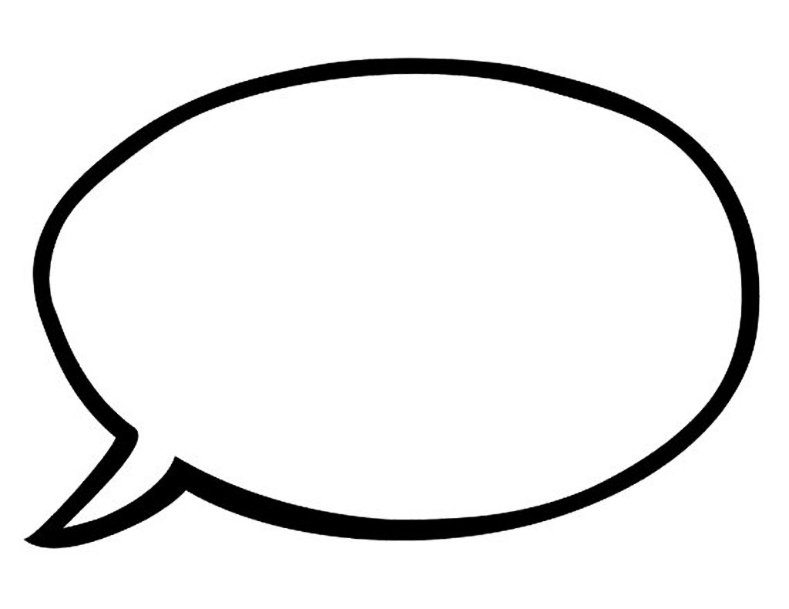 |  | - Student’s speak in complete sentences (no one word answers) to reveal understanding of the question.  - When answering a specific prompt or starting discussion, students restate the question/ provide clear context before providing an answer.
Track the Speaker   |  | Because all students’ contributions to class discussion are important, it is important that all other students listen attentively.  - Turn your eyes and body toward the speaker.  - Use silent hand signals to agree, disagree, or signal that you can’t hear the speaker.  - Notice when previous answers confirm or challenge your answer.
Support Ideas with Evidence   |  | Be prepared  - Start with focus questions answered  - Gather evidence and refer to it as needed  When students share their ideas, they need to connect back to the text/problem/example. This helps to build the skills of selecting and using evidence.  - This comment should relate directly to the topic of discussion.  - “ In paragraph____________, the text stated.” or “An example of my life is…..” “According to….”
Build on   |  | All answers are relevant to the topic.  - Multiple students respond using specific details without teacher prompting  When we have a class discussion, the purpose is for us to come to a collective understanding.  - DON’T: make a series of disconnected remarks (popcorn)  - DO: build on what others say like scoops of ice cream building on top of each other.

Independent Practice/ Homework
- Teacher sets a deadline for sharing/ turning in the final three products.
- Students complete and hand in representations.
- Teacher plans for a follow up class period to observe the multiple modes of expression and for students to respond to and provide feedback to each other’s ideas.
Lesson Close

What is the answer to the essential question, and why does it matter to me in terms of:
- Educational- Inspiration
- Vocational- Personal Mission
- Spiritual- Creativity

There are a variety of modes of communication: oral, written, and visual are only a few. In our world driven by technology, writing something down could be done in a few words or several paragraphs or pages. Saying something can include video or not and can often be shared with a simple click of a button. When we create visual messages, it is hard to know what is real and what has been filtered, edited, or completely made up. Because we have so many options on how to spread our messages, it is important to reflect on the right way to share each message based on your audience, purpose, and message. Today,you created a short message to share with a particular audience with a clear purpose in mind.
Right now, think about your message. What was your inspiration for this message? Maybe you will uncover the inspiration in the message itself- what is it you deemed important enough to share with others? Maybe you will uncover the inspiration in your purpose- what did you aim to do- persuade, inform, or entertain. What might that choice reveal about you and your values? Then, consider how you decided to deliver your message. Are you drawn to visual representations? Do you prefer a more creative or direct approach? Did you look for the “easiest” or “simplest” options or did you decide to challenge yourself. Our inspirations, our actions and decisions reveal a lot about who we are.
We know that there are messages all around us, so today you worked to make your message stand out. You know that there are a variety of ways to deliver a message. Some are often more overlooked than others. Making decisions then analyzing them will help you build your skills in reflection which are necessary in your schooling and beyond. Look at your message as a personal mission or statement about yourself. Where did you draw inspiration? How much creativity did you apply? Analyzing your own thoughts will not only help you better understand yourself, but will ensure you are clear enough that others can understand you and allow you the necessary skills to think deeply as a means to understand others.

This is the assignment page (below)!!!

Lesson 9.B

Student Name: Date:
Teacher Name: Period/Teacher:

:

Course | Unit | Content Objective: | Lesson Objective: | LYS Methodology

Assignment Instructions:

Essential Questions:

Lesson Close:

Accommodations/Modifications Provided On This Assignment:

Accommodation/Modification | Applied To This Assignment (Y/N)
Extra Time
Notes/Presentation Copy Provided
Study Sheet Provided
Graphic Organizer
Mnemonic devices
Larger Size Font
Shortened Text
Peer Support
Preferential Seating
Frequent On Task Reminders
Provided A Completed Example
Visual Organizer Provided

